

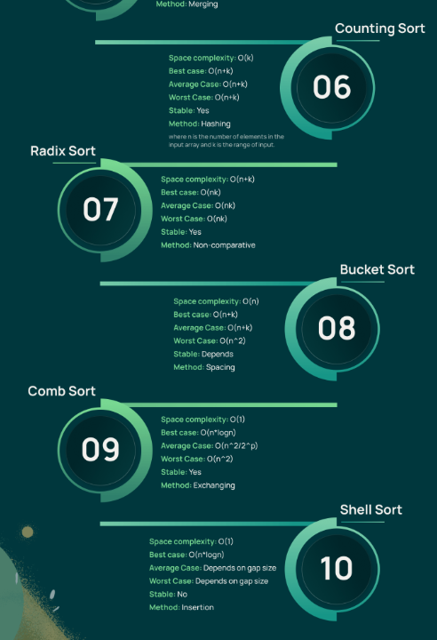

https://www.crio.do/blog/top-10-sorting-algorithms/

1)BUBBLE SORT:

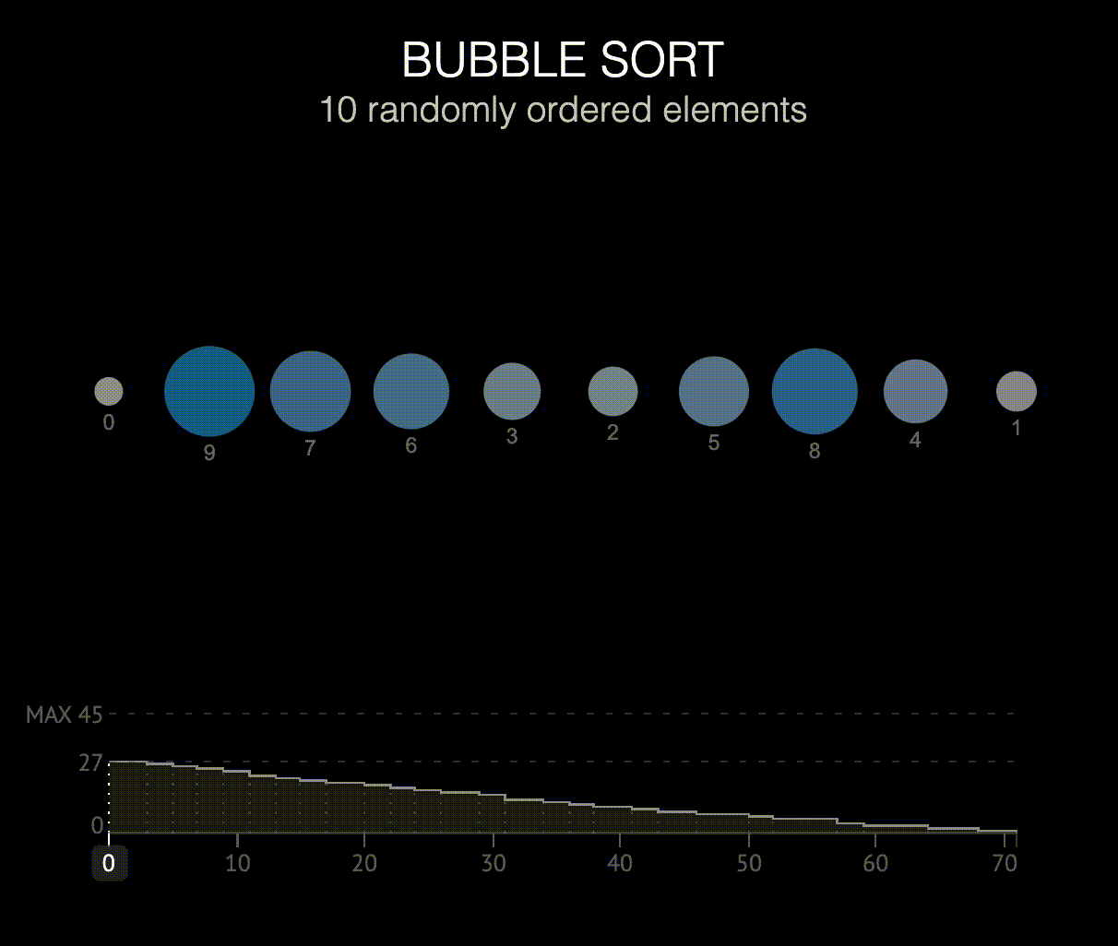

REPEATEDLY SWAP ADJACENT ELEMENT TO ATTAIN THE DESIRED LIMIT.

#include <stdio.h>

int main()

{

int n;

scanf("%d",&n);

int a[n],temp=0;

for(int i=0;i<n;i++)

scanf("%d ",&a[i]);

for(int i=0;i<n;i++){

printf("%d ",a[i]);

}

for(int i=0;i<n;i++){

for(int j=0;j<n-i-1;j++){

if(a[j]>a[j+1]){

temp=a[j];

a[j]=a[j+1];

a[j+1]=a[j];

}

}

}

return 0;

}

2)BUBBLE SORT: